TECHNOLOGY
Grade 7 • Term 1 • 2026
Name | ________________________ | Date | ________________________
Teacher | Mr Samuels | Moderator | Mrs Rosslee
Time | 4 hours | Pages | 10
Total | _________ / 70 | Percentage / NRC | ________ % | _________

PAT 1: Mini-practical assessment task - Mechanical systems and control
Skill assessed:
Learners develop a working model of a hydraulic-syringe powered, linked-lever Security Gate using simple materials.
Scenario:
Disa Primary School is upgrading its entrance to improve learner safety and access control. Currently, the school gate is manually opened, which causes delays and safety risks during busy drop-off and collection times.
The school would like to install a low-cost automatic gate system that uses a hydraulic mechanism to open and close smoothly. The system must be safe, reliable, and easy to operate, even during load shedding. A manual override must be included so the gate can still work when there is no electricity.
The design must:
- Open and close smoothly
- Include a visible safety feature (colour marking or symbol)
- Stop or slow when an obstruction is detected
- Include a manual backup system
- Be suitable for frequent daily use
Model Requirements:
- Base: 40 cm × 20 cm
- Gate: ±15 cm high and ±30 cm wide
- Materials: Cardboard, plastic sheets, wooden sticks, syringes, tubing, rubber bands
- Budget: Maximum R150
The gate must include levers or linkages to improve movement and control. The model must clearly show how a learner would safely operate it.
INVESTIGATE [15]
Investigation: (7)
True or false: Syringes can be used to make things move. ____________________ (1)
What is the difference between a pneumatic and hydraulic mechanism? (2)
______________________________________________________________
______________________________________________________________
______________________________________________________________
Instead of water what type of liquid is usually used in a hydraulic system? (1)
______________________________________________________________
State TWO advantages of using a hydraulic system in machines such as car jacks or lifts. (2)
______________________________________________________________
______________________________________________________________
______________________________________________________________
2. Complete the Design Brief, Specifications and Constraints (8)
Write a design brief (3)
Design a ____________________________ (what is needed?) for the ____________________________ (who will use it?) that will be used to ____________________________ (what is it for?).
List 3 specifications. (3)
______________________________________________________________
______________________________________________________________
______________________________________________________________
List 2 constraints / limitations on the materials. (2)
______________________________________________________________
______________________________________________________________
Initial idea sketches (A4-size)
Create freehand drawings and focus on the concepts. Use different line types. Write notes next to sketches.


DESIGN [20]
Draw one view of the 2D working drawing with dimensions (8)
This drawing must be done on graph/grid paper.
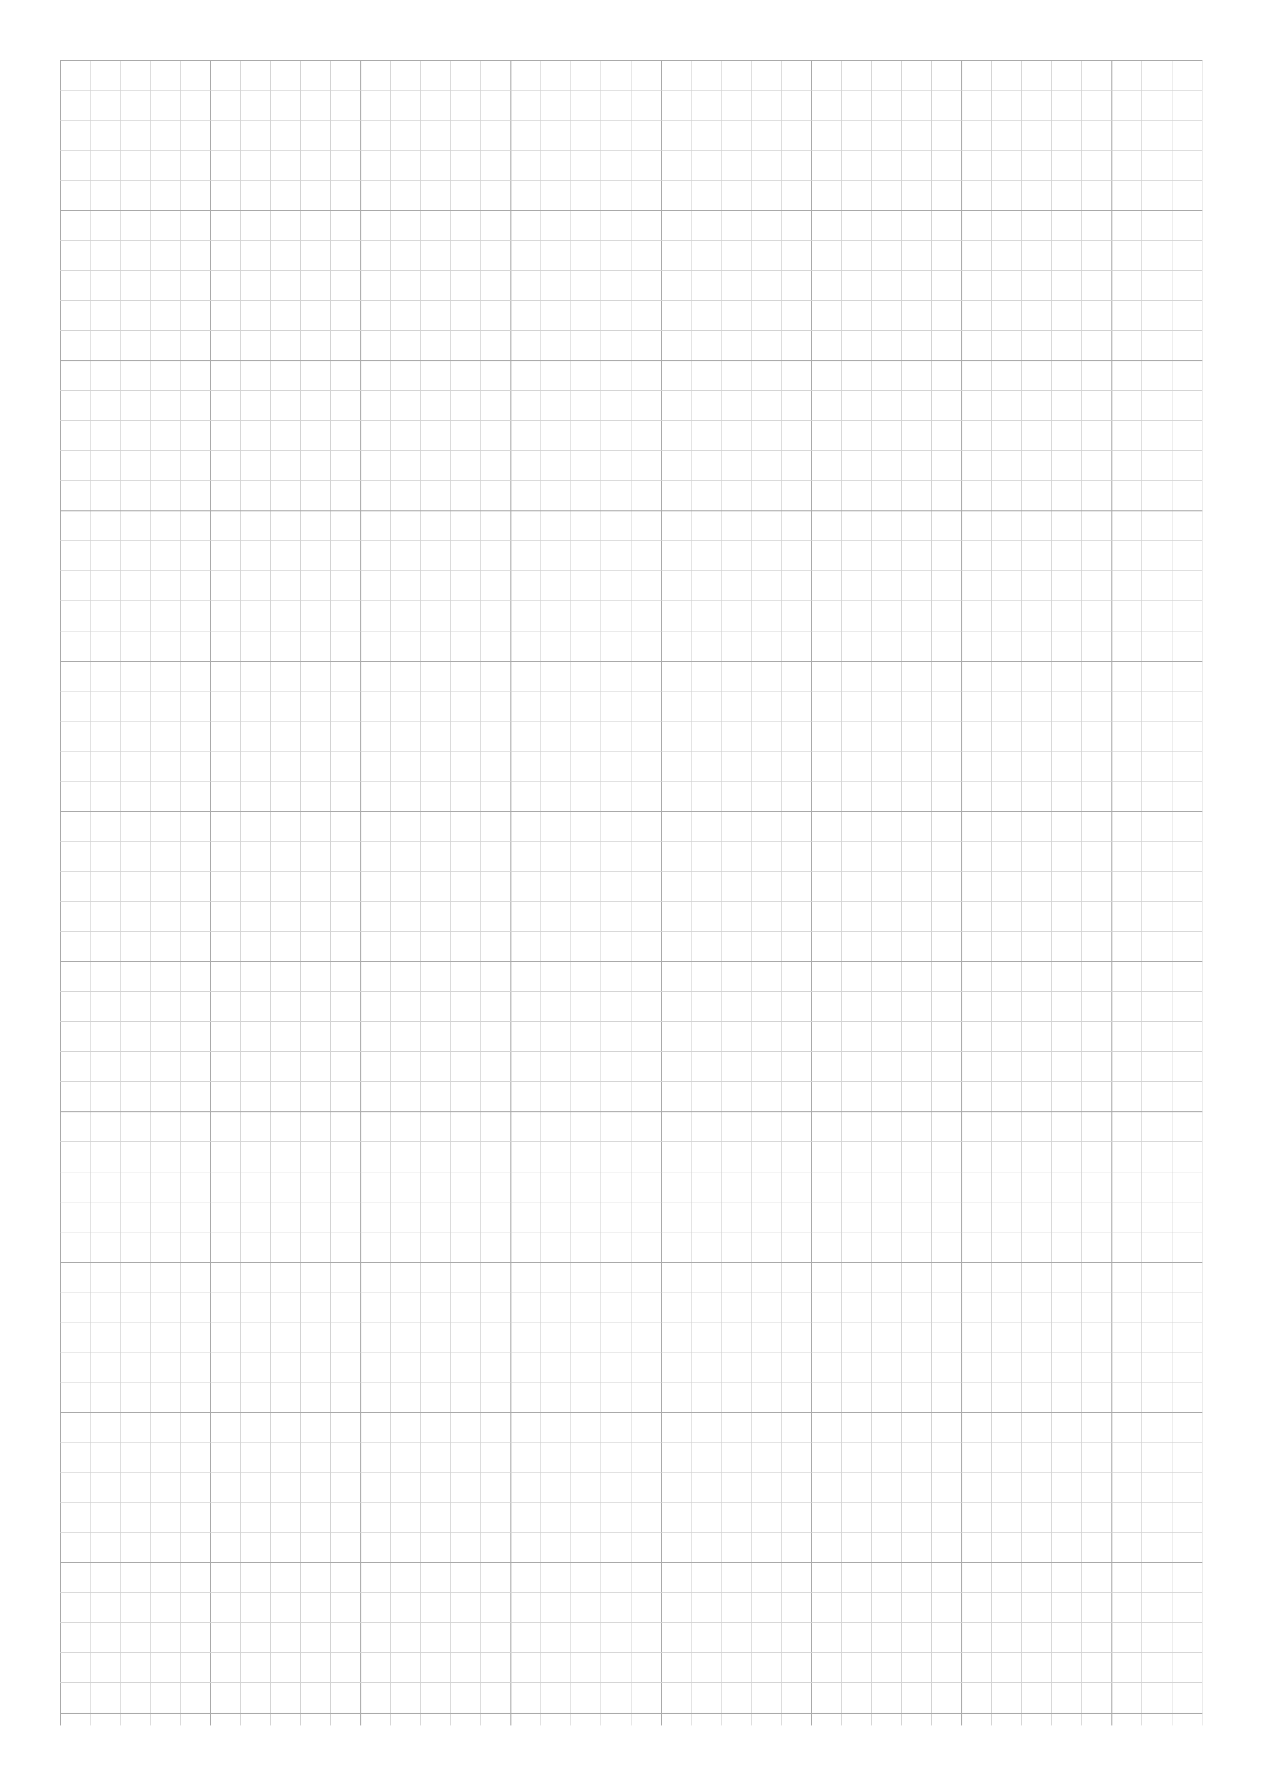

Draw a 3D oblique projection (12)
This drawing must be done on graph/grid paper.

MAKE [35]
Planning how you will make your model (15)
3.1 Materials list (4)
______________________________________________________________
______________________________________________________________
______________________________________________________________
______________________________________________________________
3.2 Tools list (4)
______________________________________________________________
______________________________________________________________
______________________________________________________________
______________________________________________________________
3.3 Two safety rules (2)
______________________________________________________________
______________________________________________________________
3.4 Order of work (Flowchart) (5)
Do NOT use graph paper here.

